RISHIT BURMAN
📚 Intelligent Financial Document Engine - Project Documentation

🚀 Overview
This project presents a robust Intelligent Document Retrieval System designed to handle the extraction, semantic indexing, and question-answering over financial documents. It leverages powerful AWS services including Textract, DynamoDB, S3, SageMaker, and OpenSearch for secure, scalable, and efficient processing of enterprise documents — while keeping data private (no use of public LLMs).

🎯 Why This Project Matters
Business Impact
- Automates the reading and searching of thousands of financial reports, audit documents, quarterly filings, etc.
- Eliminates manual efforts by finance teams, saving hours of time per document.
- Ensures accuracy using semantic search powered by embeddings.
- Keeps enterprise data completely private and never leaves AWS.
Potential Use-Cases:
- 🔎 Financial firms (for annual/quarterly report analysis)
- 🏥 Hospitals and pharma (for report lookup & compliance)
- 🏢 Enterprises (for internal document retrieval)
- ⚖️ Law firms (for fast document clause retrieval)

🧱 Architecture Breakdown
🧩 Part 1: Document Upload & Text Extraction
Flow:
- 📁 User uploads a PDF/Scanned image to S3 Bucket (doc-engine-bucket-risbur).
- 📌 A PUT event triggers a Lambda function named doc-upload-processor.
- 🧠 This Lambda uses Amazon Textract to extract structured text from the uploaded document.
- 🧾 The text and document metadata (like file name) are stored in DynamoDB table DocumentTextTable.
✅ Why Amazon Textract?
- It supports scanned financial documents (images, tables, PDFs).
- Can extract text from complex layouts with high accuracy.
- Fully serverless and scalable.

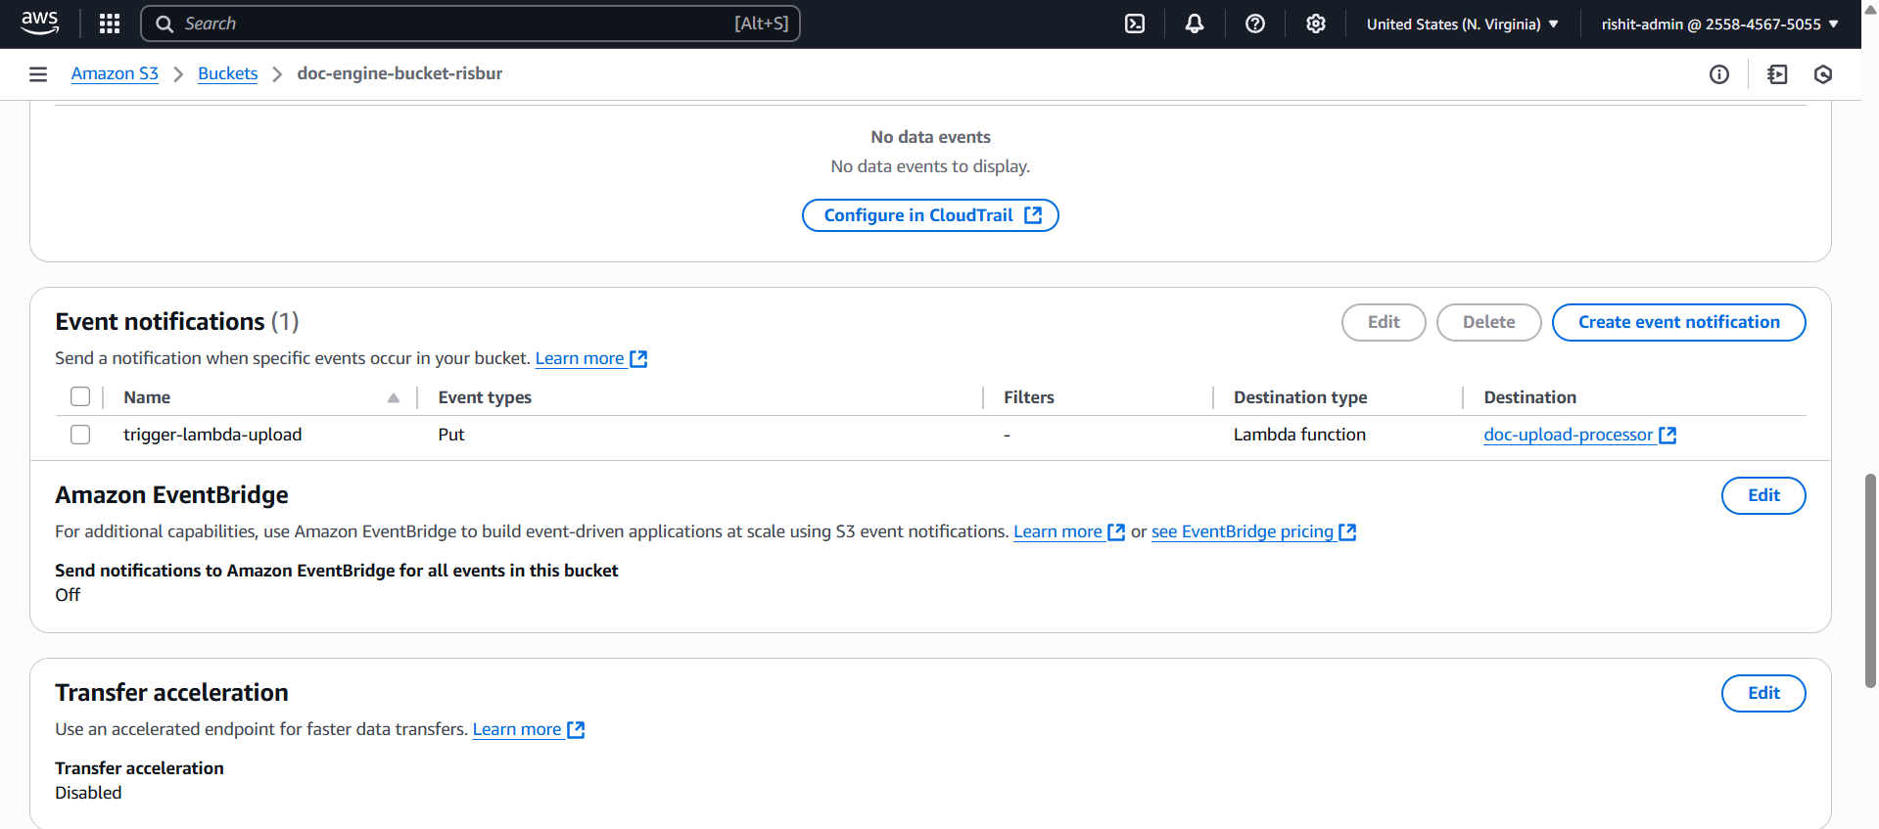
- Upload event from S3 triggering Lambda.
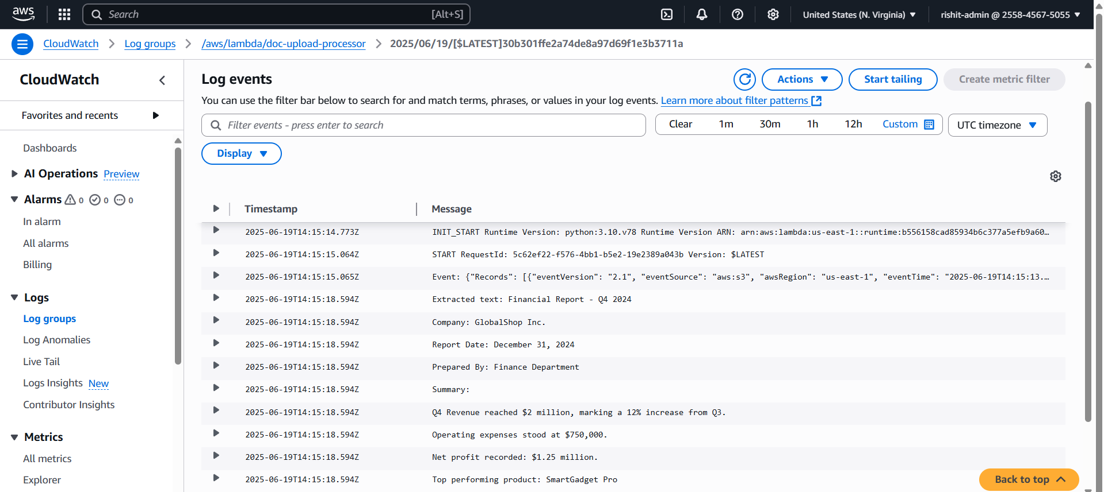
- Extracted Textract output from CloudWatch logs.

🤖 Part 2: Embedding Generation & Semantic Indexing
Tool: Jupyter Notebook (generate_embeddings.ipynb)
- Loads each document’s text from DynamoDB.
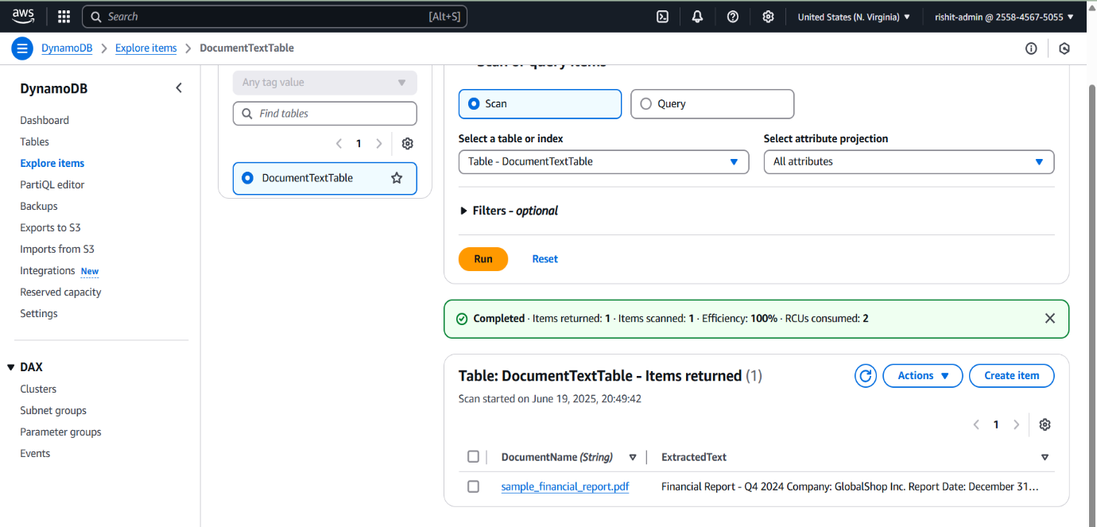
- Uses a SentenceTransformer MiniLM model hosted on SageMaker to generate text embeddings (vector representations of document meaning).
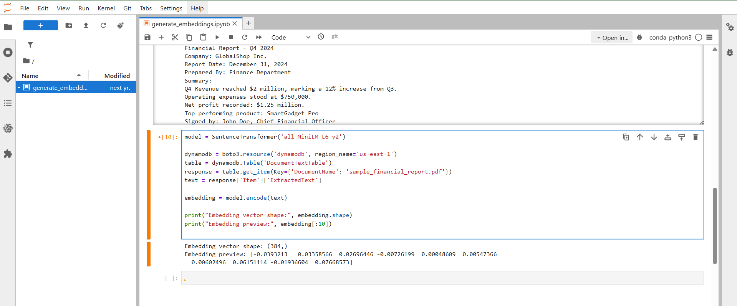

- Embeddings + metadata are stored in OpenSearch (KNN Index) for fast semantic retrieval.
- Output of generated embeddings.
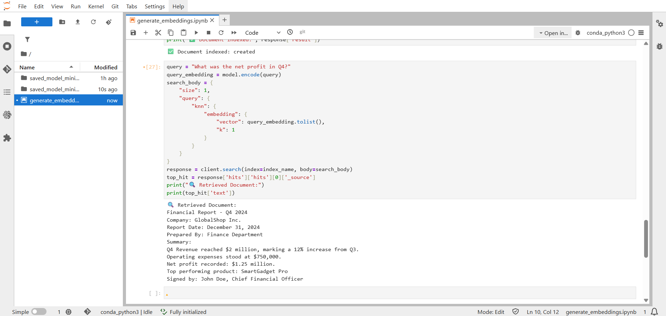
- Indexing confirmation on OpenSearch dashboard.
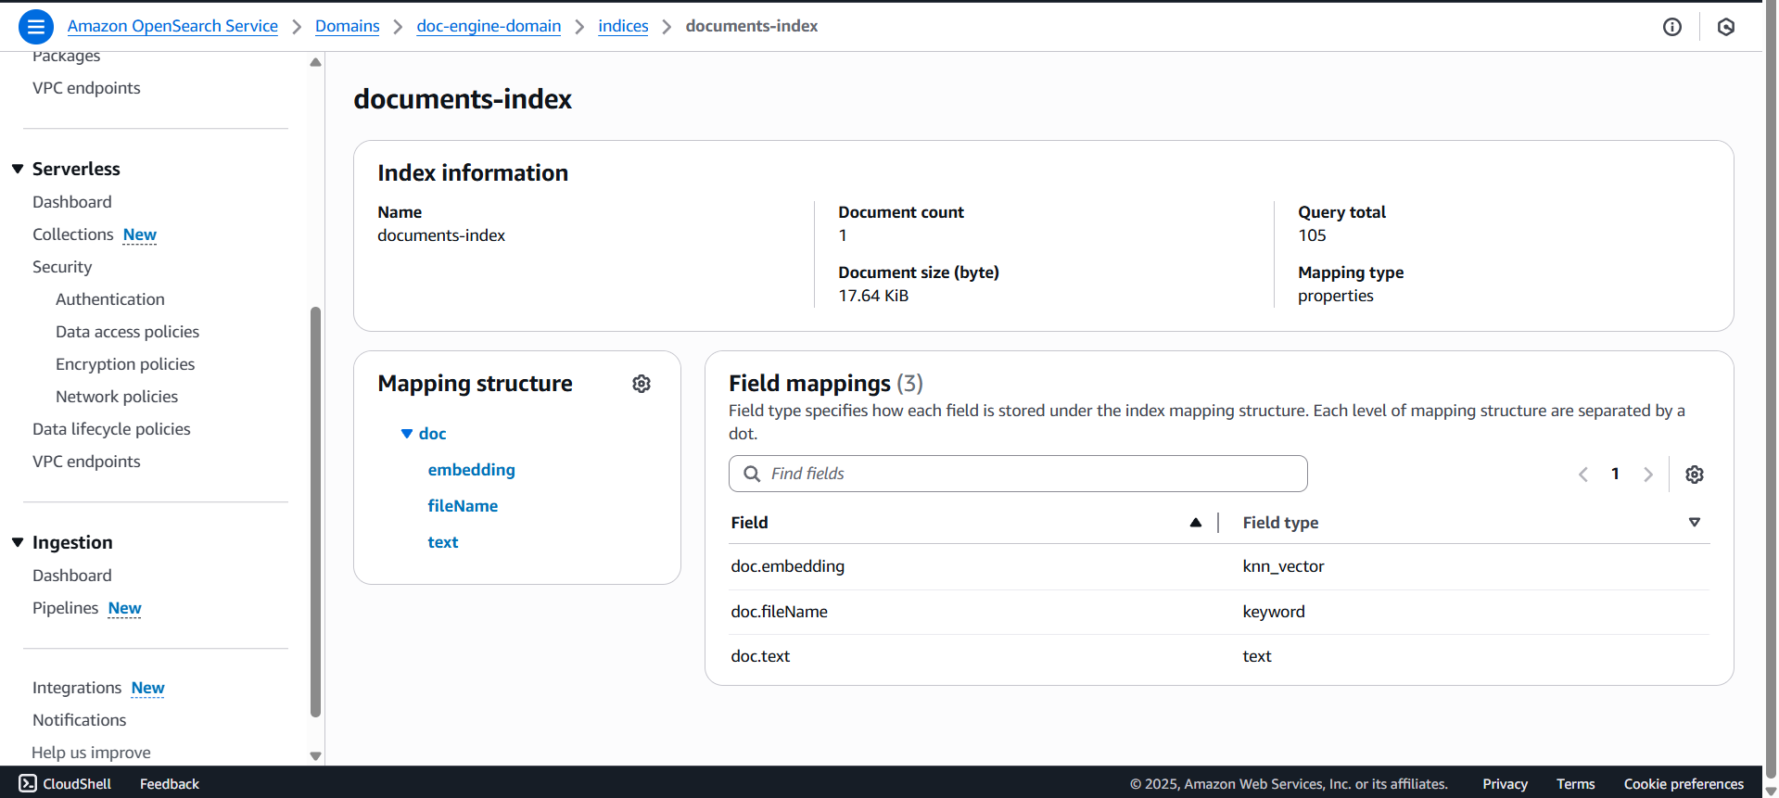

🔎 OpenSearch Vector Database — How It Works
OpenSearch’s KNN indexing allows you to:
- Store high-dimensional embedding vectors (from SageMaker).
- Perform Approximate Nearest Neighbour Search on these vectors.
- Retrieve most semantically relevant document based on the user's question.
Example:
Query: "What is the net profit?"
OpenSearch returns the document that has the closest vector embedding to this question and pulls the matching line.
Advantage over keyword search:
- Can handle paraphrased queries (e.g., “profit for the quarter” → “Net profit recorded: $1.25 million”).
- Robust even when documents use different wordings.
- OpenSearch index view.
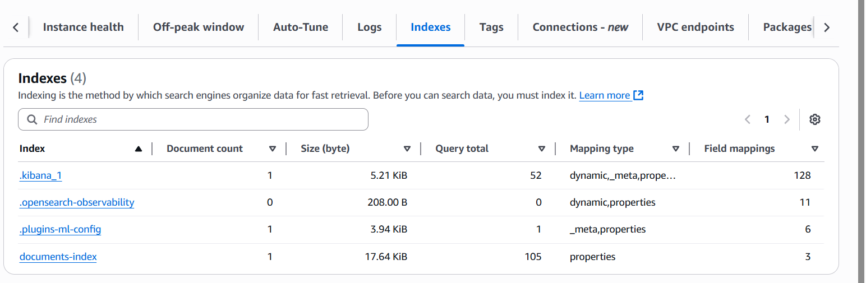

- Search query payload and matching result.
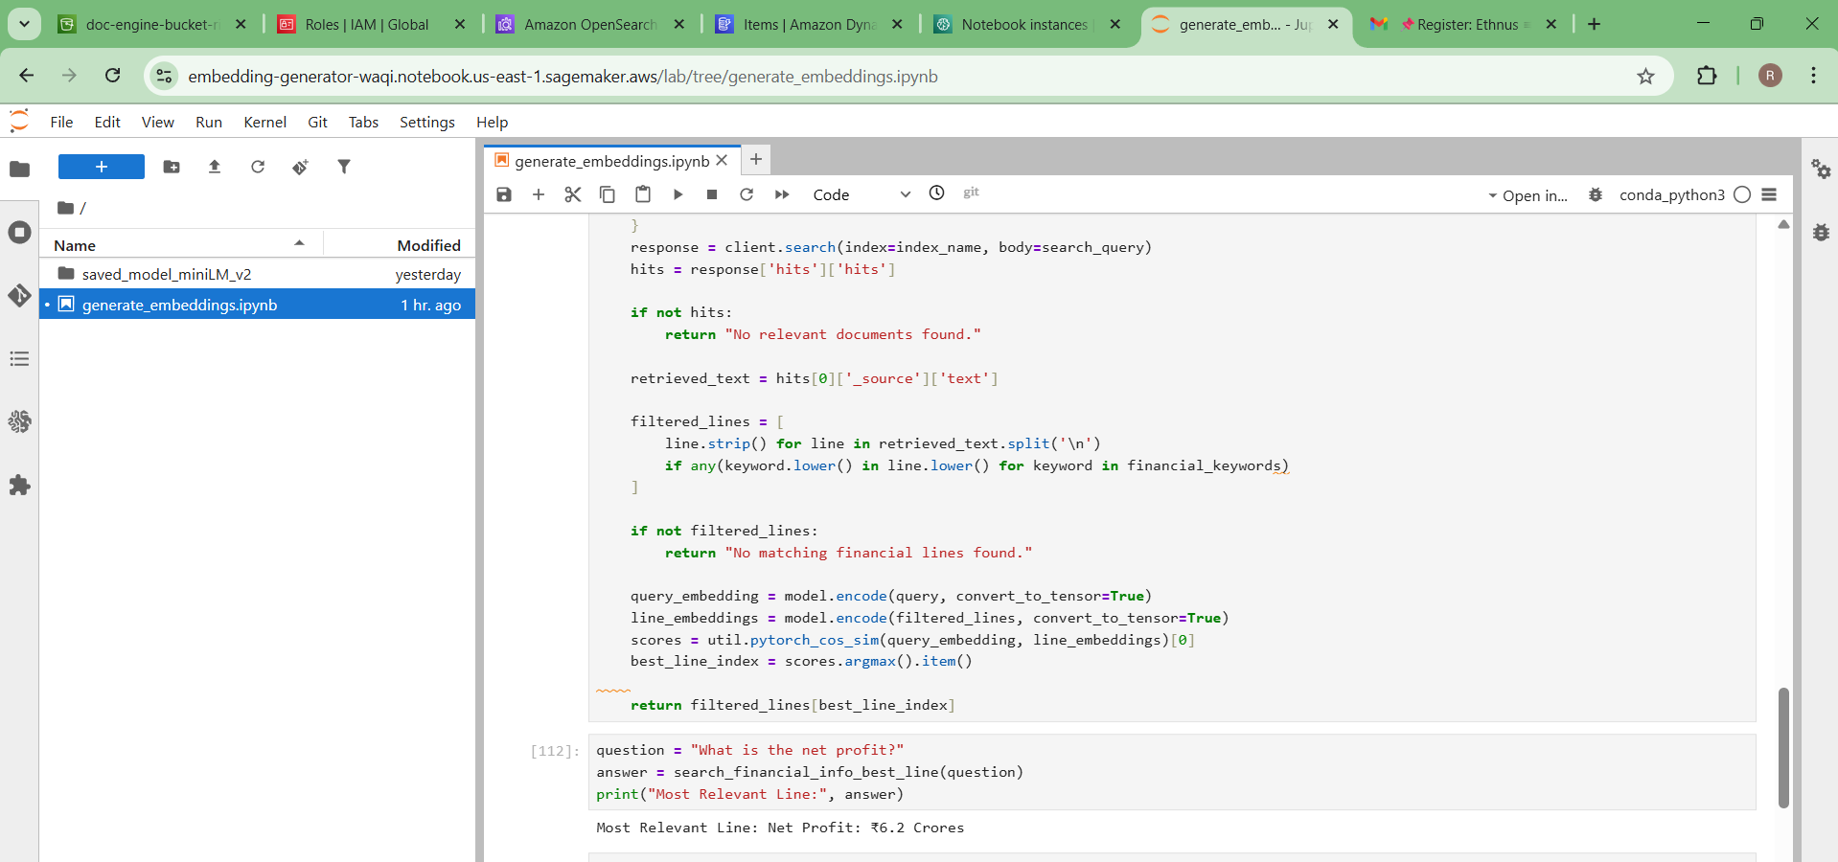

🌐 Streamlit Frontend App
Functionality:
- Web UI for users to ask questions about uploaded financial documents.
- Loads the model dynamically from S3.
- Searches across all indexed documents and returns the most relevant answer line.
- No document selection needed — all searches are aggregated.

- Streamlit interface with user question.
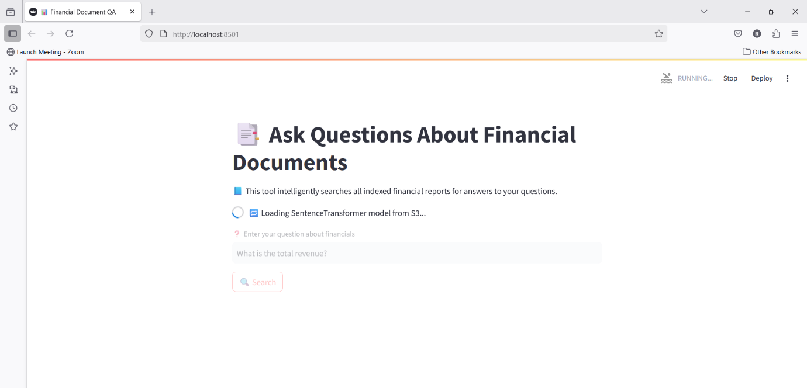
- Output with the most relevant line highlighted.
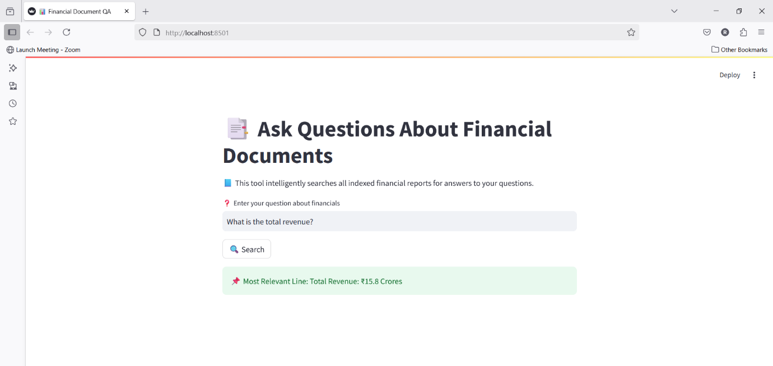

🗂️ Project Structure
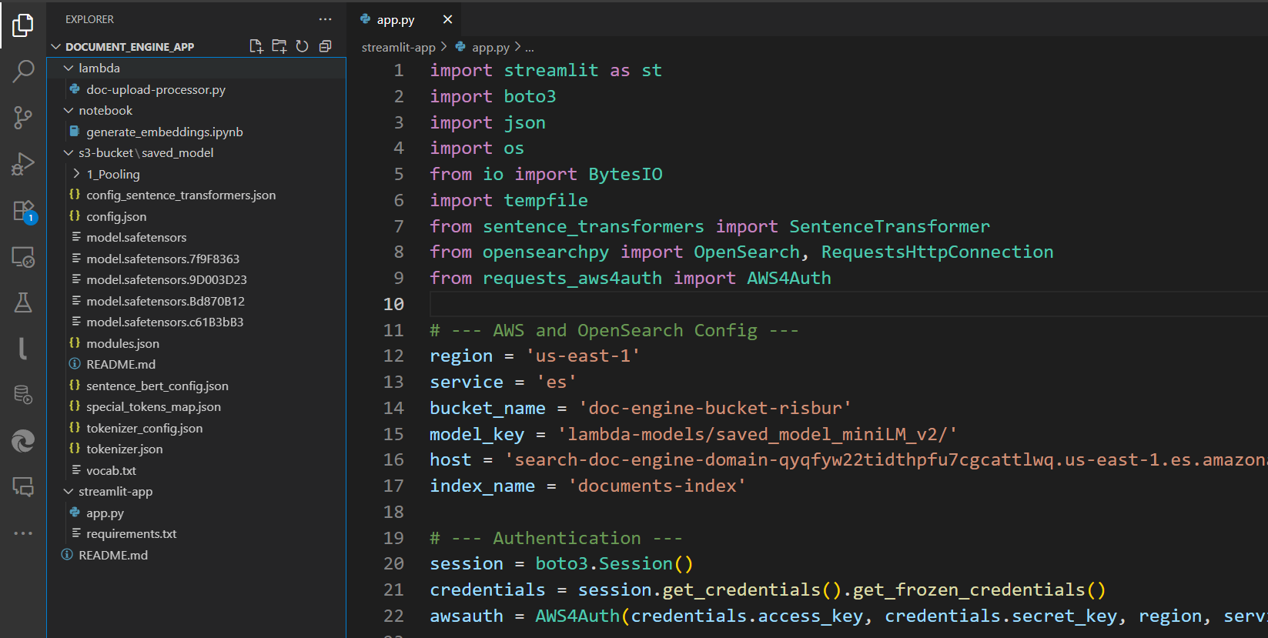

🧪 Technologies Used
Component | Technology
Text Extraction | AWS Textract
Storage | S3, DynamoDB
Embeddings | SentenceTransformer (MiniLM)
Model Hosting | SageMaker
Vector Index | OpenSearch KNN
App Frontend | Streamlit
Deployment | EC2 t2.micro (Free Tier)
Authentication | Boto3 + SigV4 (requests- aws4auth)

✅ Benefits Recap
- 🔒 Privacy First: No data goes to third-party LLMs.
- 🚀 Fast Search: Instant semantic answers from large documents.
- 🧠 Contextual Understanding: Not just keyword matching.
- 💼 Industry-Ready: Applicable in finance, law, healthcare.

📝 How to Run the Project
1. Upload Financial Docs to S3
S3 Bucket: doc-engine-bucket-risbur
Trigger Lambda: doc-upload-processor
Stores in: DocumentTextTable
2. Run generate_embeddings.ipynb
Generates vector embeddings & stores in OpenSearch index.
3. Launch Streamlit UI
bash
CopyEdit
streamlit run app.py

- ✅ S3 document upload interface.
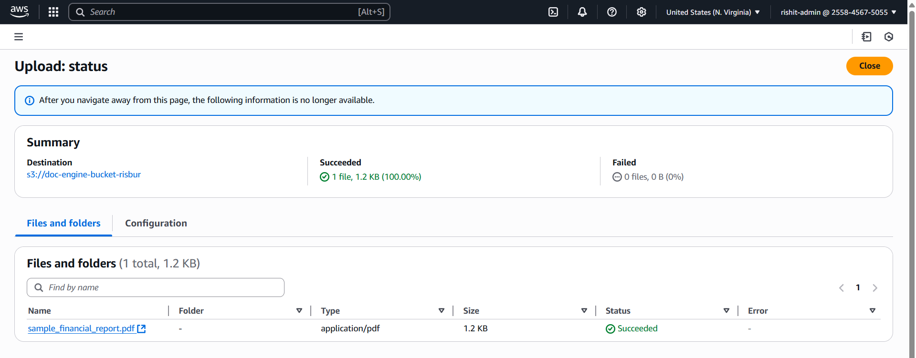
- ✅ Lambda execution log showing Textract.

- ✅ DynamoDB console showing text records.
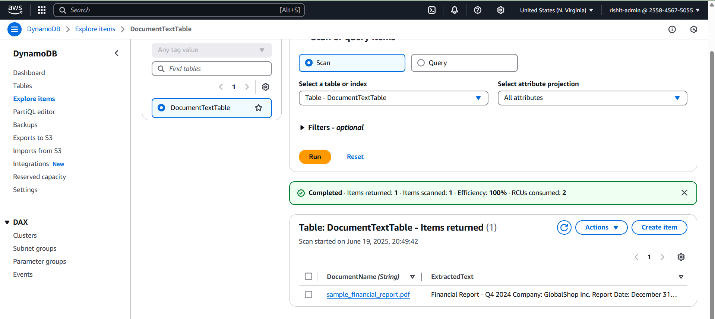
- ✅ SageMaker embedding generation outputs.
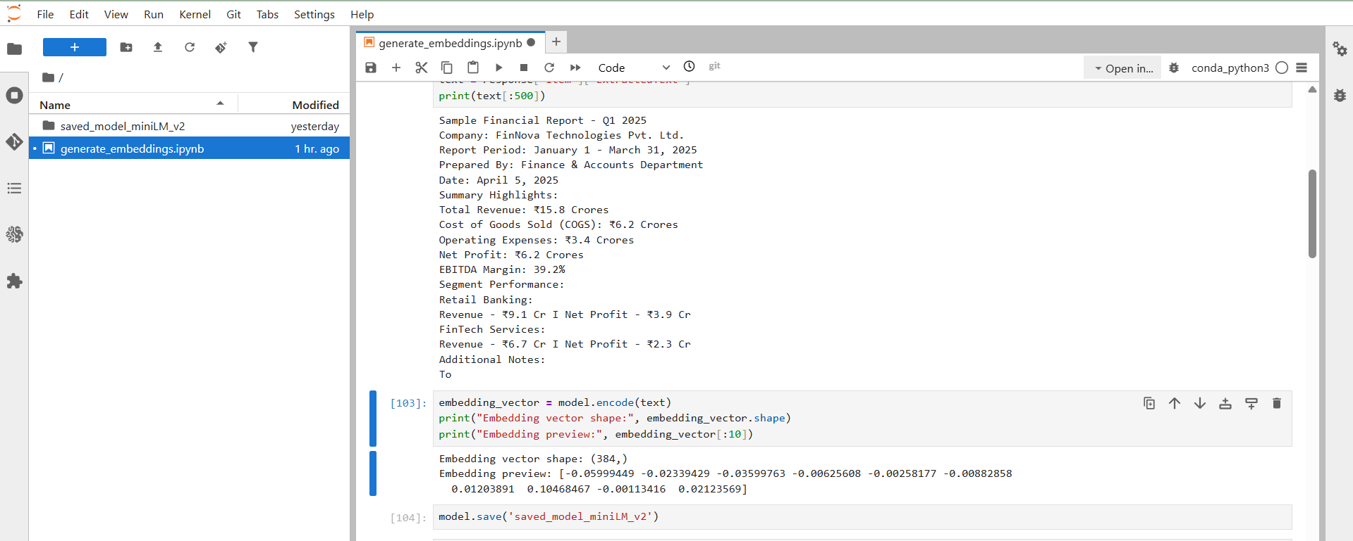

- ✅ OpenSearch dashboard (index + knn).
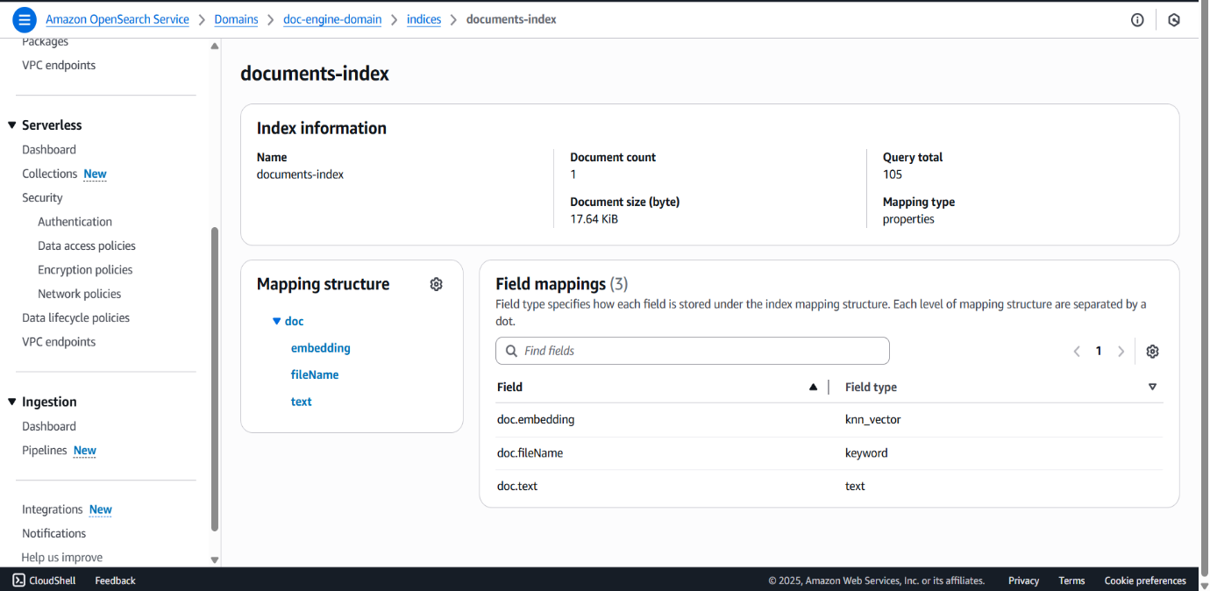
- ✅ Streamlit UI answering questions.
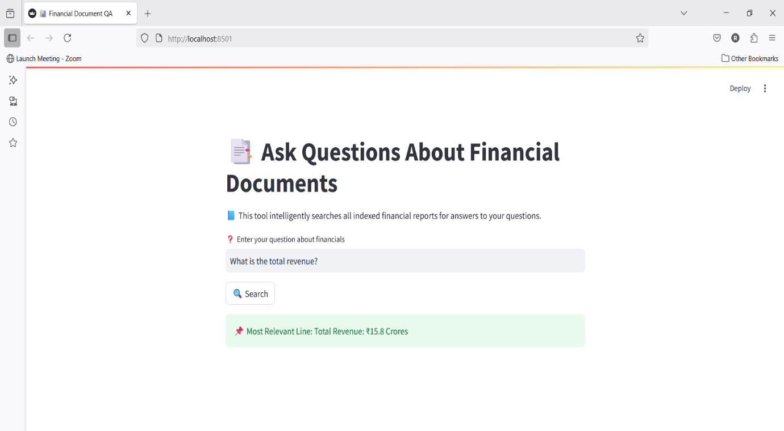

- ✅ IAM Roles configuration
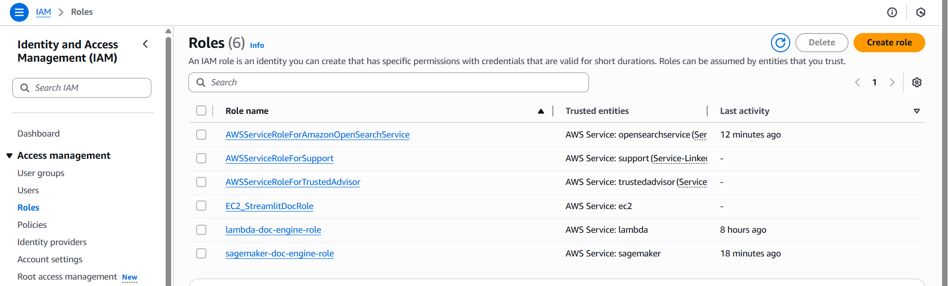
☁️ Hosting the Streamlit App on AWS EC2
To make the application accessible publicly and ensure scalability, I deployed the Streamlit-based Q&A interface on an Amazon EC2 instance using a Linux AMI (Amazon Machine Image) with the Free Tier t2.micro configuration.
🔧 EC2 Configuration Details:
Configuration | Value
AMI | Amazon Linux 2
Instance Type | t2.micro (Free Tier eligible)
Storage | 8 GB EBS (General Purpose SSD)
Security Group | Allowed inbound traffic on ports 8501 (Streamlit), 22 (SSH), and optionally 80 for HTTP
Key Pair | Generated and used for SSH access securely
Public IP Assignment | Enabled (auto-assigned)

🧪 App Deployment Steps on EC2
Here’s how I deployed the Streamlit application:
- SSH into the EC2 instance:
ssh -i my-key.pem ec2-user@your-ec2-public-ip
- Installed required system packages:
sudo yum update -y
sudo yum install python3 git -y
- Created a virtual environment:
python3 -m venv venv
source venv/bin/activate
- Cloned the GitHub repo containing my Streamlit app:
git clone https://github.com/rishit911/document_engine_proj.git
- Installed Python dependencies:
pip install -r requirements.txt
- Configured AWS credentials using aws configure to authenticate with SageMaker, OpenSearch, and S3.
- Ran the Streamlit application:
streamlit run app.py --server.port 8501 --server.enableCORS false --server.enableXsrfProtection false
- Kept the Streamlit app running persistently using nohup:
nohup streamlit run app.py &
- Accessed the app via browser using:
http://3.110.245.87:8501
🧑‍💻 Personal Learnings & Project Reflections
🔄 What I Learned
Working on this project was a deep dive into real-world cloud engineering, MLOps, and AI automation. It helped me:
- ✅ Understand end-to-end data pipelines from ingestion (S3) to processing (Lambda & Textract) to storage (DynamoDB) and retrieval (OpenSearch).
- ✅ Gain hands-on experience with semantic search using vector databases and SageMaker model serving.
- ✅ Learn to orchestrate multiple AWS services securely using IAM roles, boto3, and SigV4 authentication.
- ✅ Improve my debugging and deployment skills — from local dev on Streamlit to hosting on EC2 (free-tier t2.micro).
- ✅ Structure and document a scalable, modular, and production-grade cloud-native application.

⚠️ Mistakes I Made (and Fixed)
- ❌ Initial Misconfigurations in OpenSearch domain endpoint caused timeout errors — I learned how to use correct hostname syntax and adjusted connection retries.
- ❌ I tried to load heavy ML models inside Lambda, which exceeded size limits. I pivoted to SageMaker inference endpoints for scalability.
- ❌ Model saving/loading errors (due to meta tensors and PyTorch 2.x issues) taught me the value of version compatibility and lazy loading models from S3 dynamically.
- ❌ Initially added dropdown document selection in Streamlit — later realized aggregating search across all documents was more useful and user-friendly.

🛠️ How This Project Prepares Me for a Cloud Engineer Role
- 🧠 Showcases my ability to integrate multiple AWS services into a functional, cloud-native solution.
- ⚙️ Demonstrates my understanding of event-driven architectures using Lambda and Textract.
- 📦 Proves my skills in deploying scalable apps on EC2, including dependency handling, model loading, and real-time querying.
- 🔐 Highlights secure authentication practices using AWS4Auth and boto3.Session.
- 📊 Combines machine learning, data engineering, and cloud operations in a unified solution.

